**17 marzo**

LINKED DATA

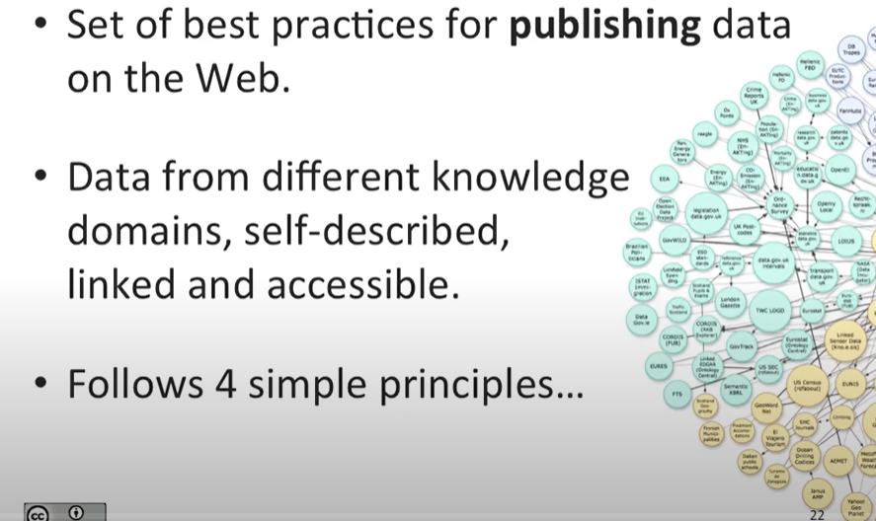

Overlap between knowledge graph and linked data

Linked data:

* set of best practices for publishing data on the web.
* Data from different knowledge domains, self-described, linked and accessible
* Follows 4 simple principles

Linked data principles

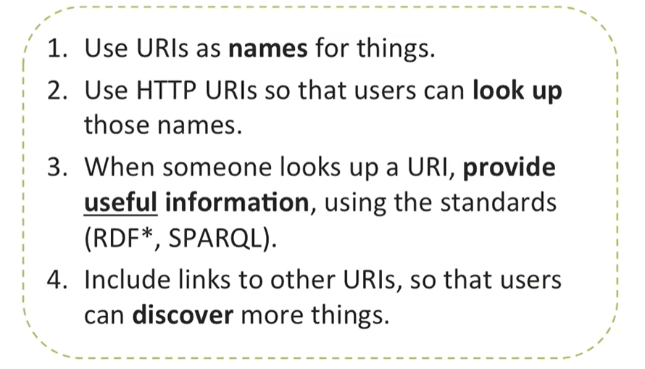

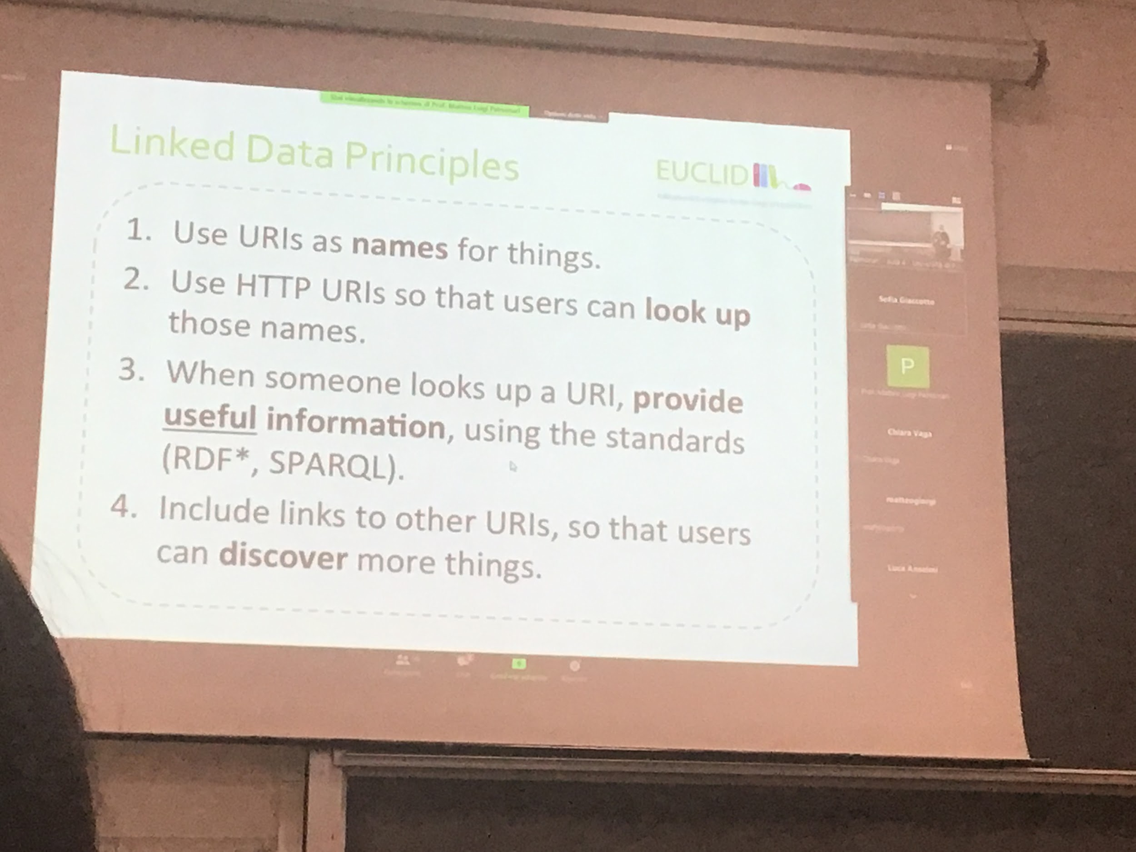

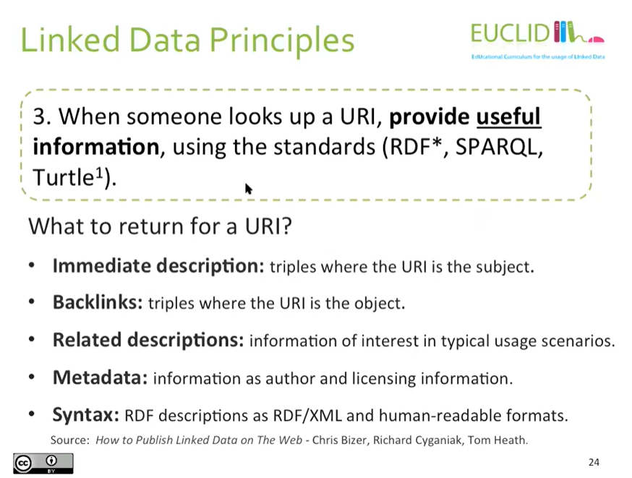

Immediate description: triples when uri subject

Backlinks: uri is the object

Is dio:artist of: is a backlink

owl:nameAs predicate

Pointing to an identifier of the same entity in other knowledge graph

Wikidata:

The idea behind is to do what wikipedia does for textual information but with data

LOD Dataset on the Web

Open data: an important movement that has the aim to release data (especially the one produced by the government) accessible. Data that is openly available

Linked open data: open data that is linked together

Linked open data cloud: virtual set of data, openly available, able to take an URI and get information.

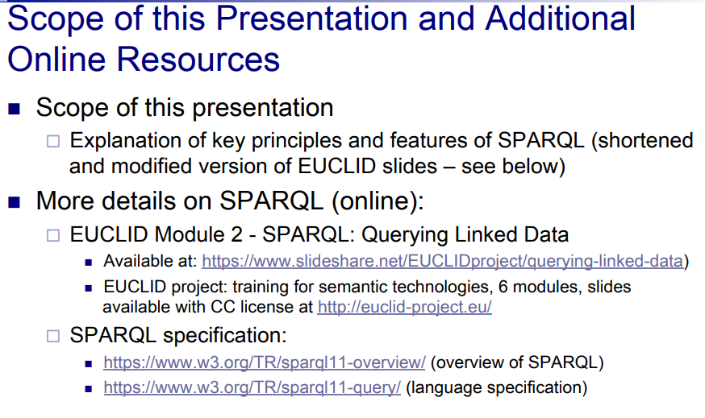

Find factual answer based on the informations store in the KB

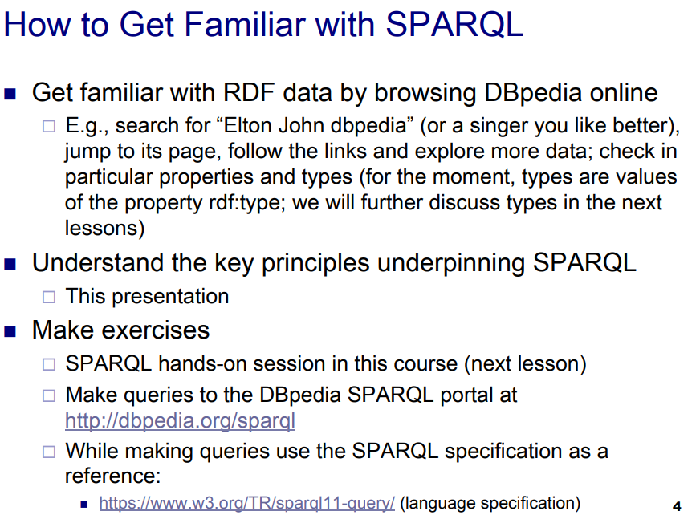

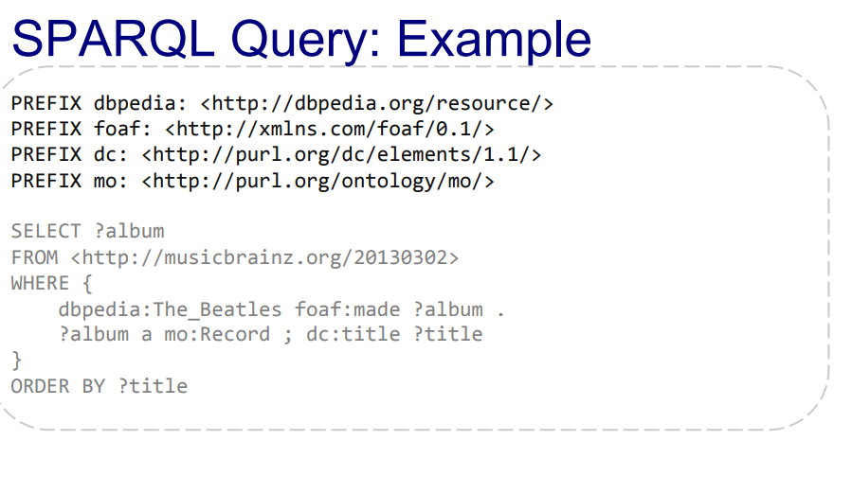

SQL: query language for relational at abase

SPARQL: based on SQL

Declare and use prefix

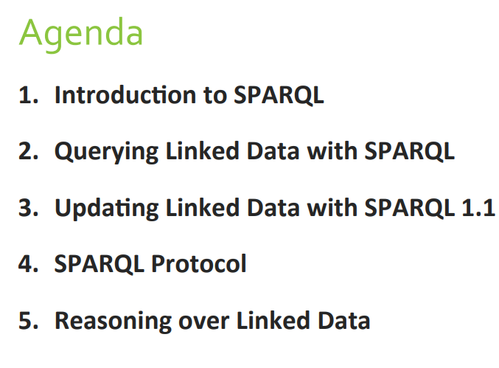

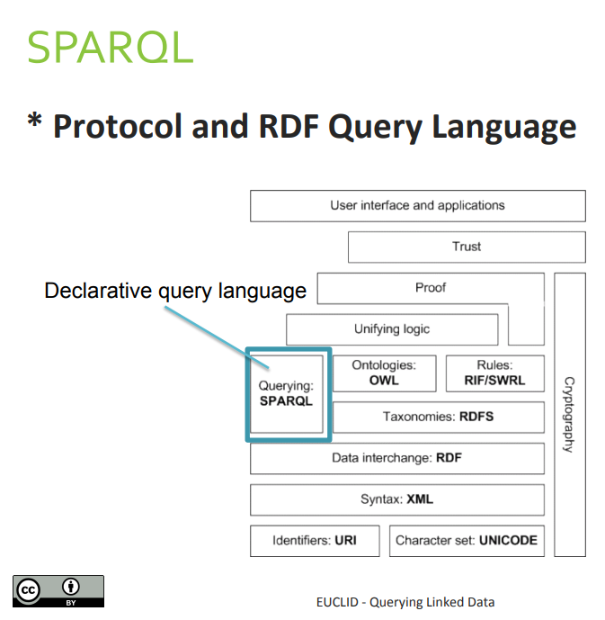

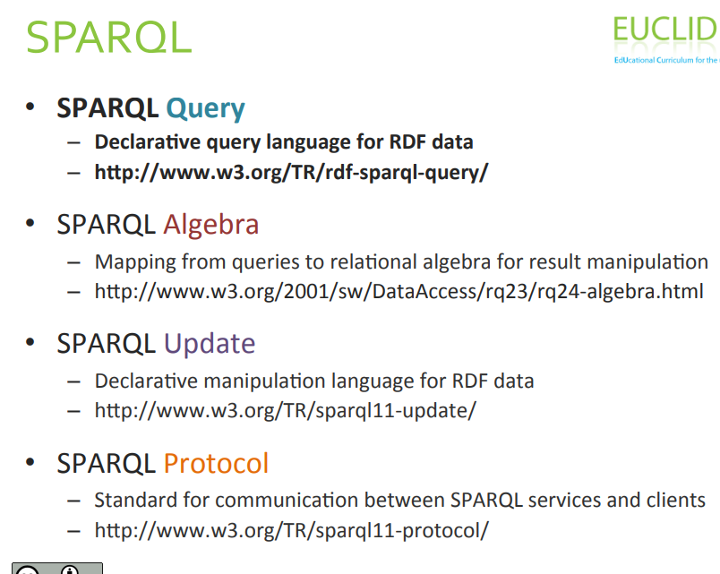

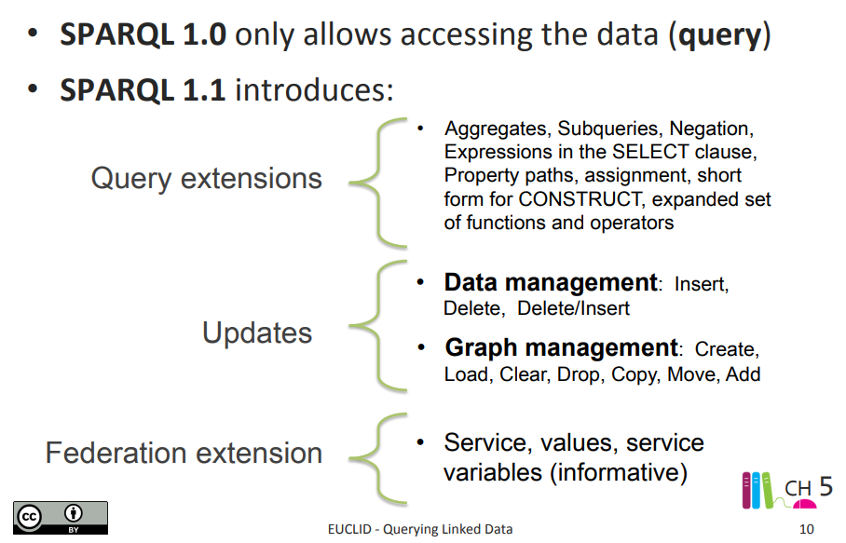

Property paths

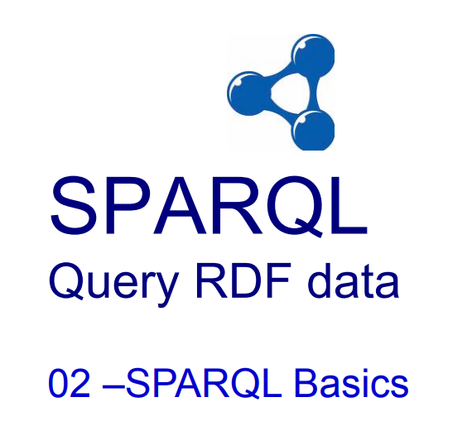

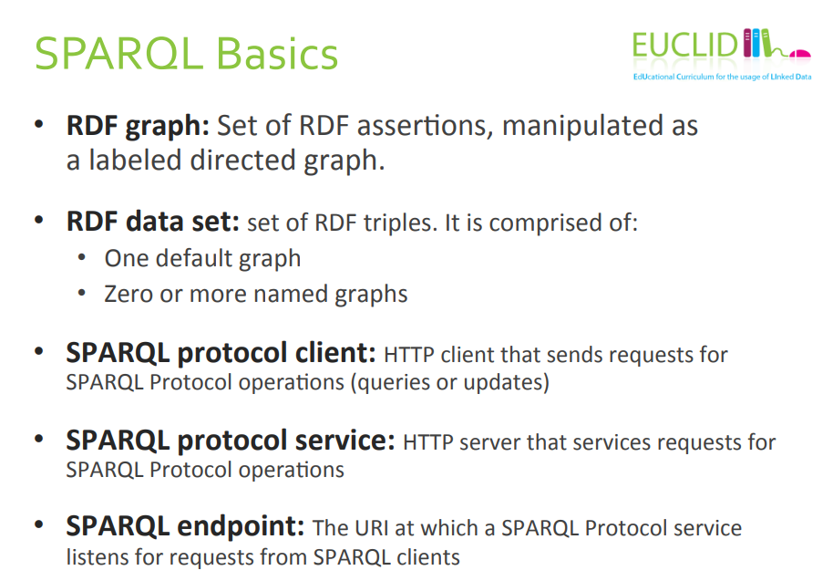

RDF graph: we manipulated the assertions as a label directed graph

RDF data set: we always con iR graph from a theoretical point of view. In practice is useful to partito on our knowledge in different graphs

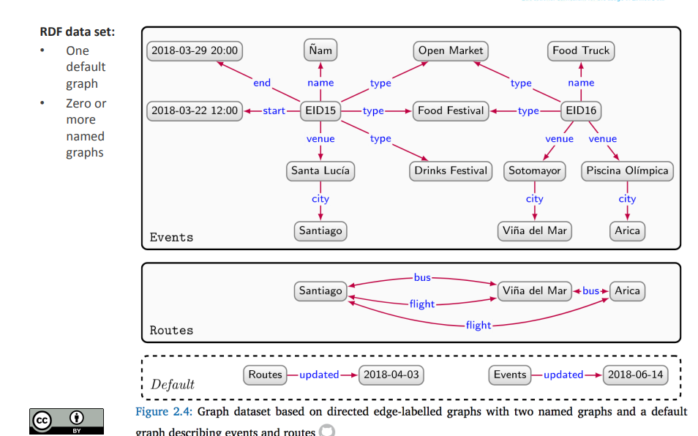

The first graph represents events

The second represents roots

The third graph is default, use the names that we used in the last graph to tell when they have been updated

Use multiple graphs because it faster to query, or faster to update

From a logical point of view there is no difference

RDF Tuples: because they are triple, also called statements. To represent a stremente we need a triple, but we could use four elements

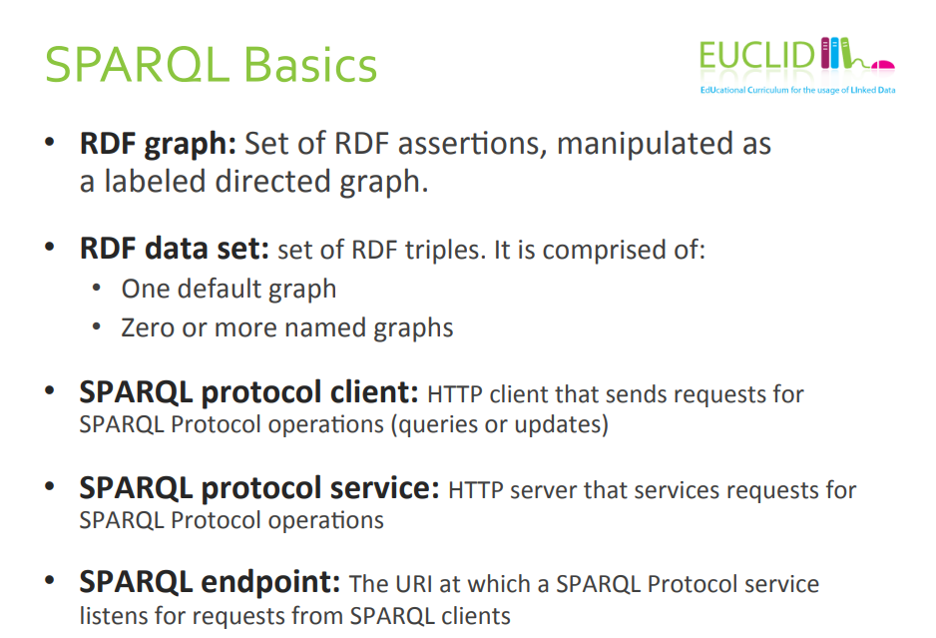

The client sends request for a SPARQL and the serve is in charge to replay to that request

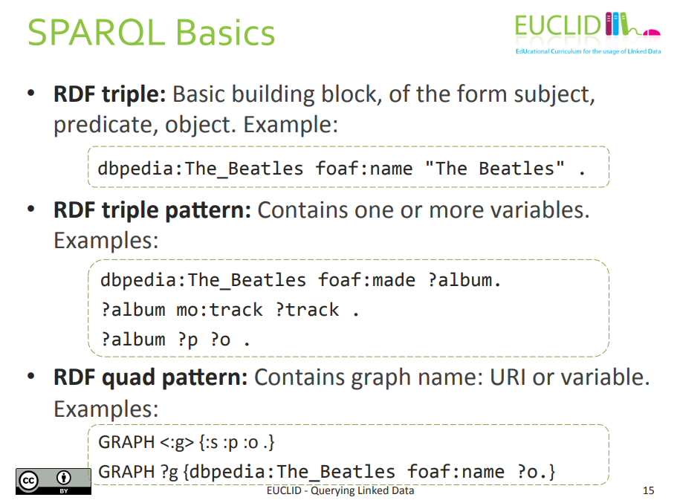

RDL tripe is the building block

Rdf triple pattern: indursi of URL, blank notes for subject, only url for predicate and, blank note, url and literal for object we can also have variables

Variable with ? At front

We can have the same variable in different queries

What is the difference between blank note and variable?

Blank nodes are names, they look like some sor of variables but they are not, more similar to skolem constant (is a constant, you can not quantify on top of a skolem constant, you use it locally)

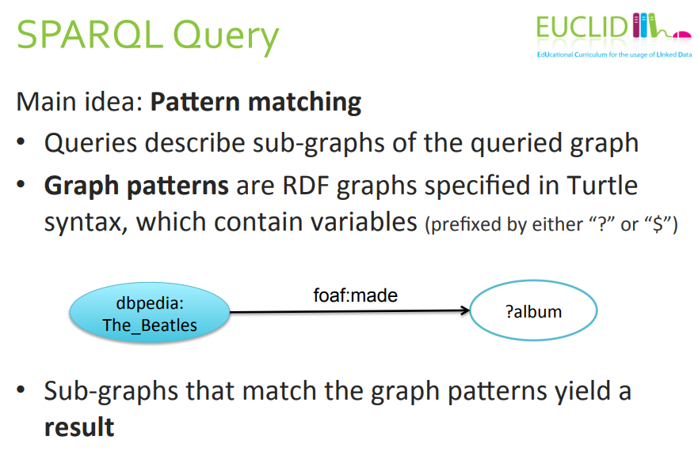

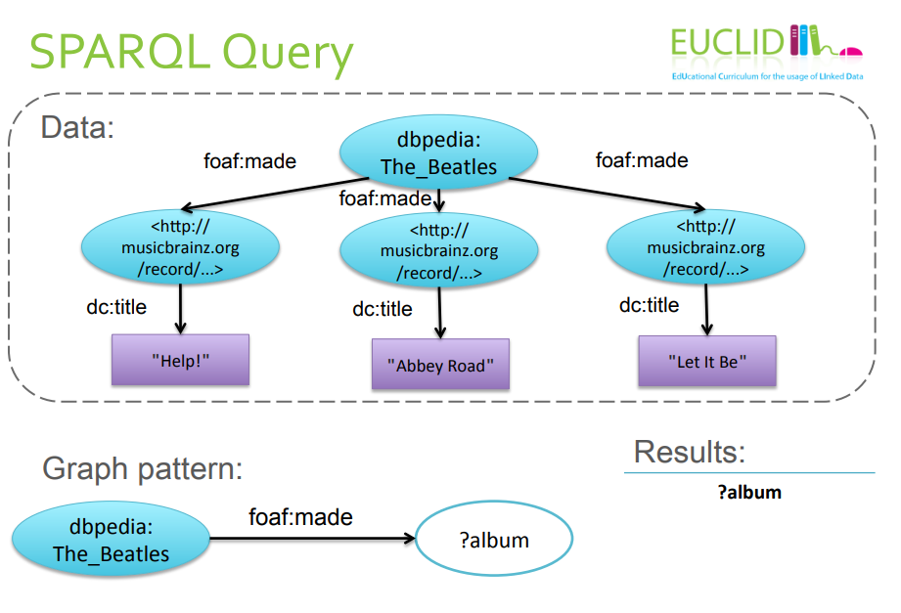

Three results:

What are the results?

Since we have a set fo variable the result is the value of the variable???

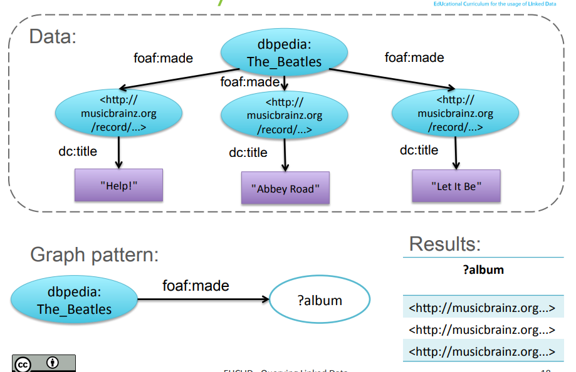

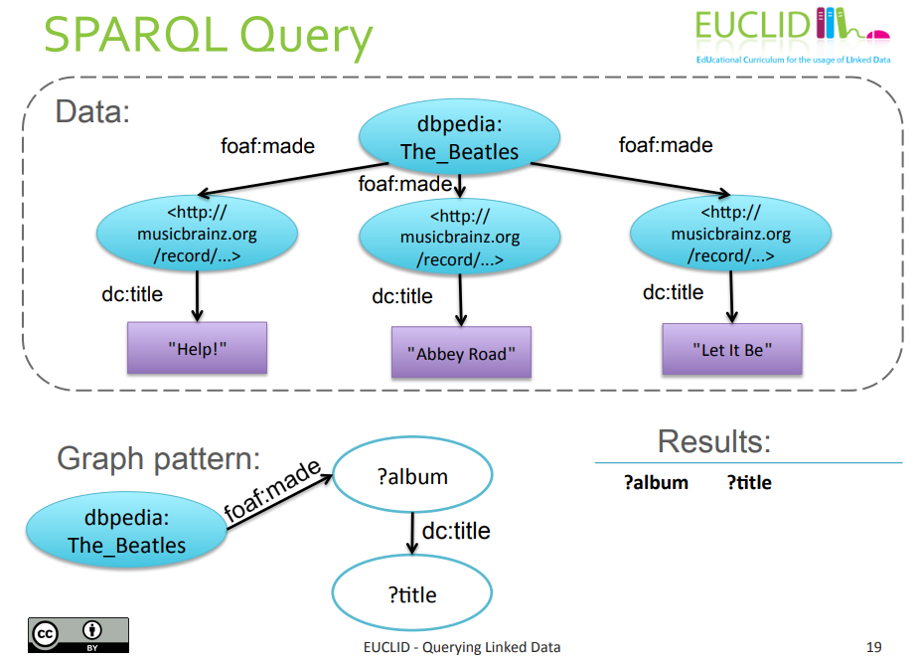

?album and ?title are variable

How many substitution for the two variables we find in such a way that if we replace such variable is a subse of the main

3 rows

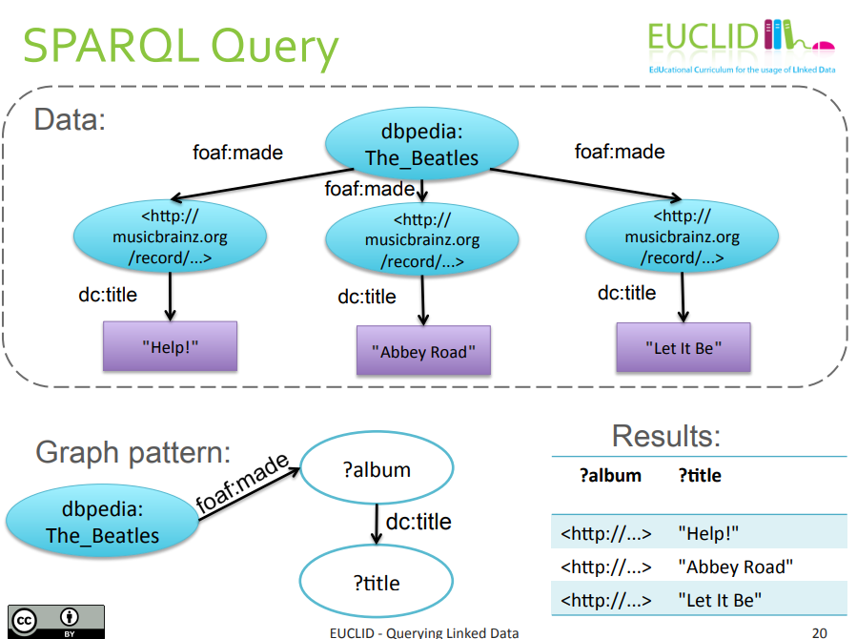

One of the subastino of album with the first one and title “help”…

Why we don’t mix up because there is no edge

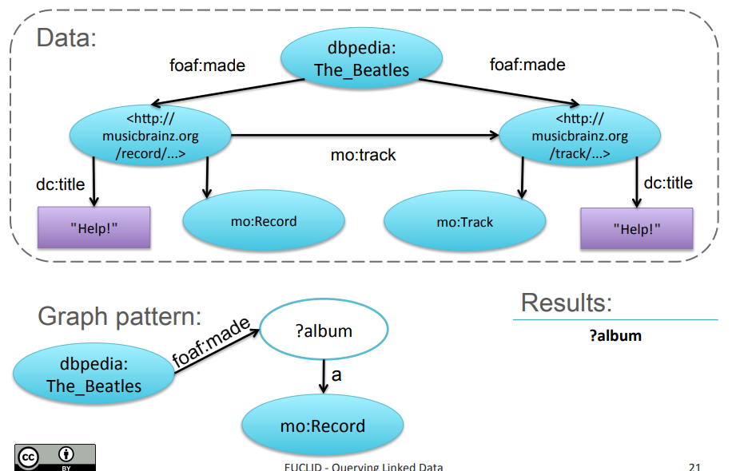

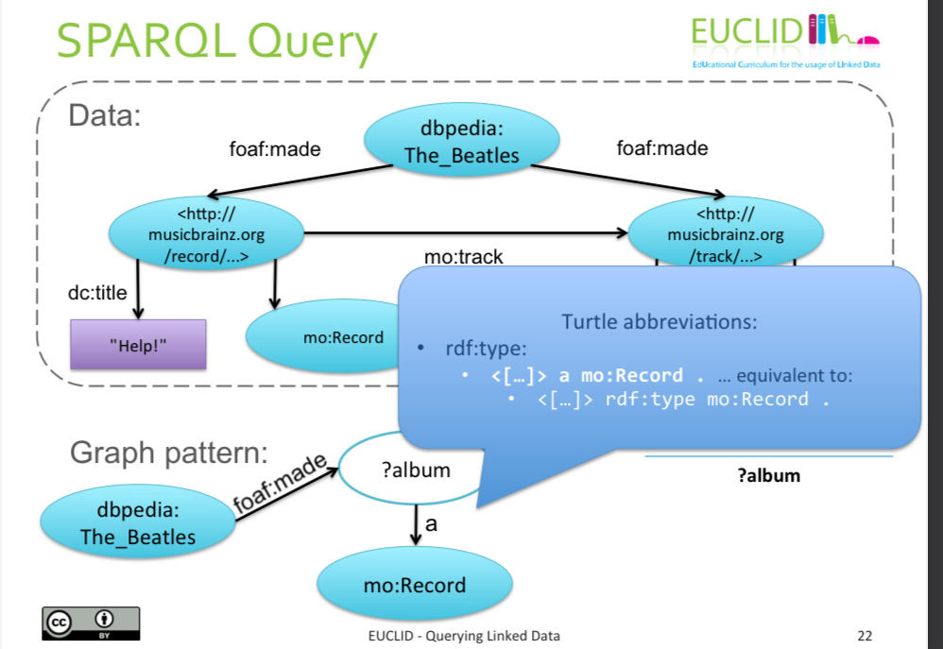

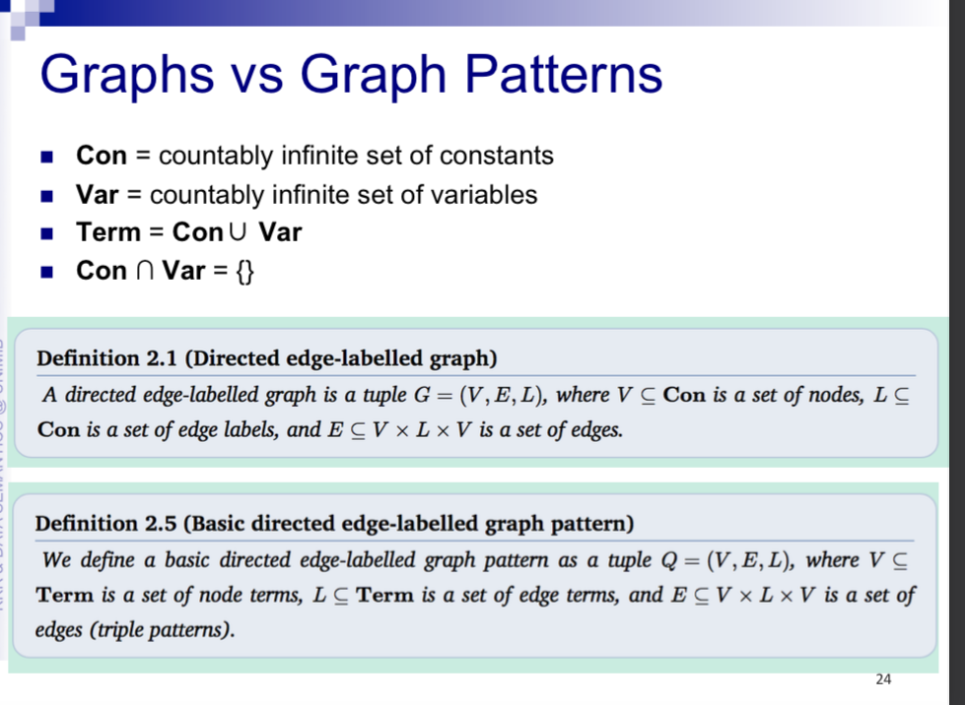

+completare cos è van

Constabld and variable are disjoint

E: set of triples

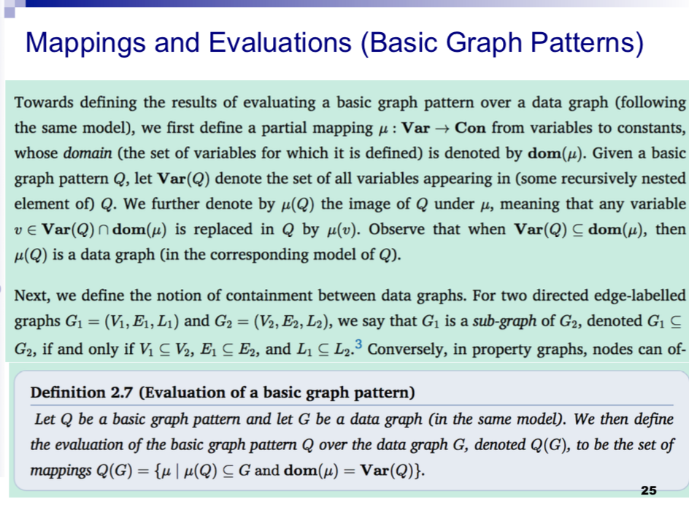

The only the difference between graph ∏ graph patterns is that we also have variables and term+completare

μ esplablish a partial mapping between variables and constant

Any variable that basically belongs to q and also to the mapping is replaced by this term

A substitution is a function where to each variable we map a variable to a constant

If the garble of q is a ⊆ of the domain of μ then the ima

If every variable can be mapped the graph pattern becomes a data graph

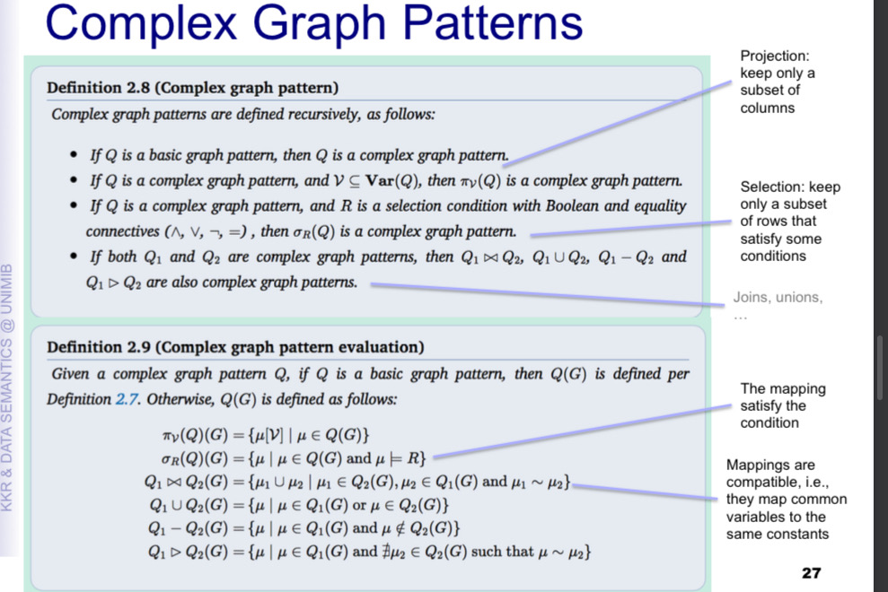

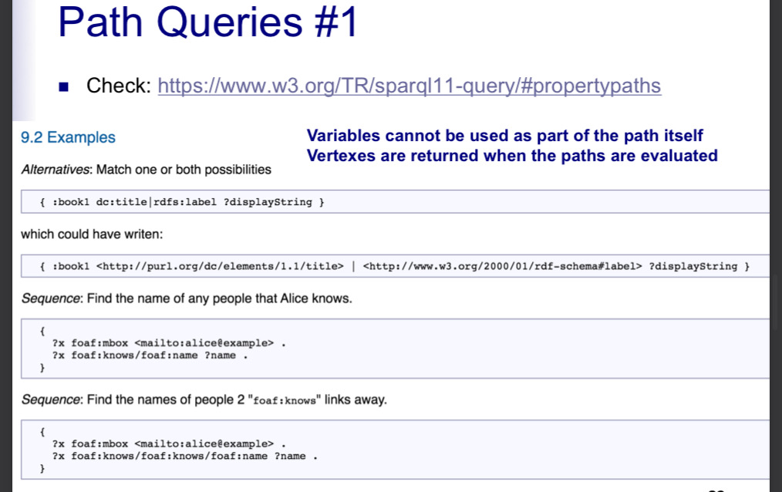

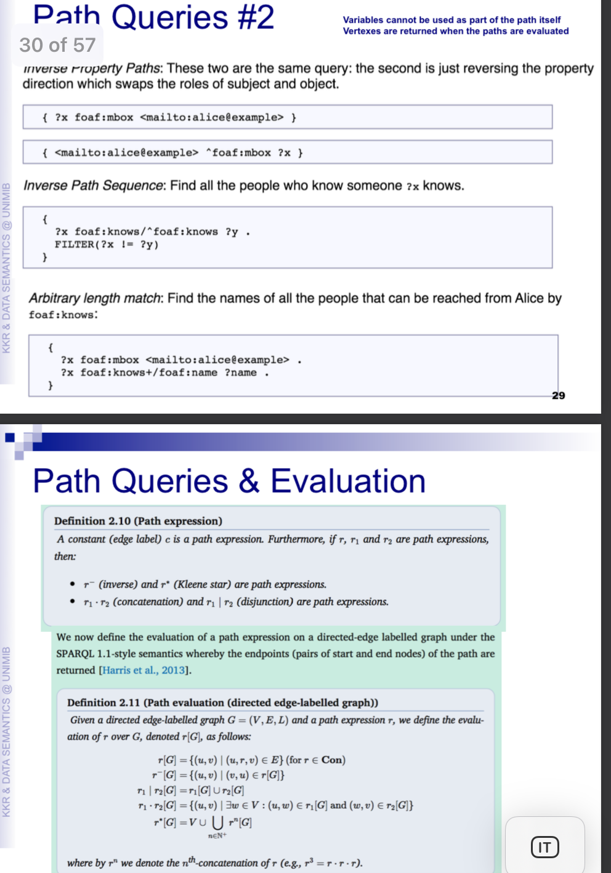

QUERY FORM

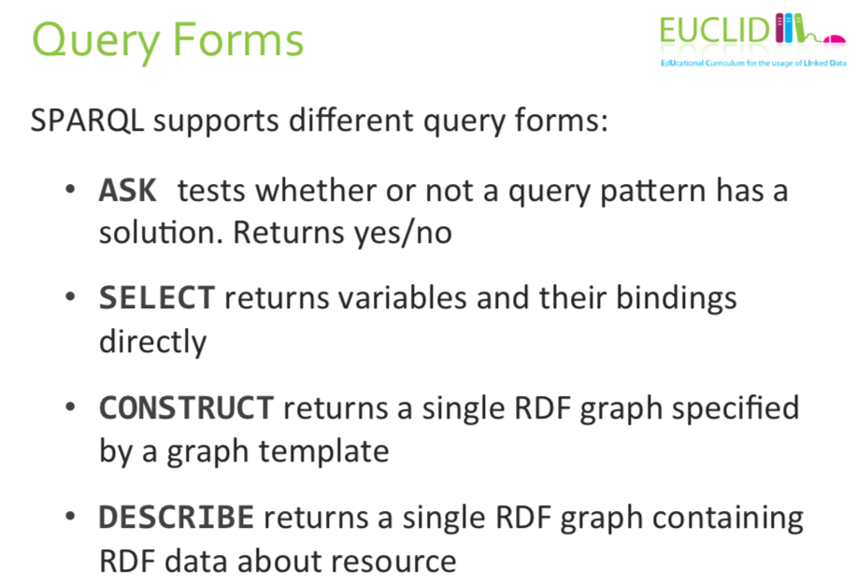

Ask if the solution ∃ or not

If the temple is empty the answer is false, if the table is not false the answer is true

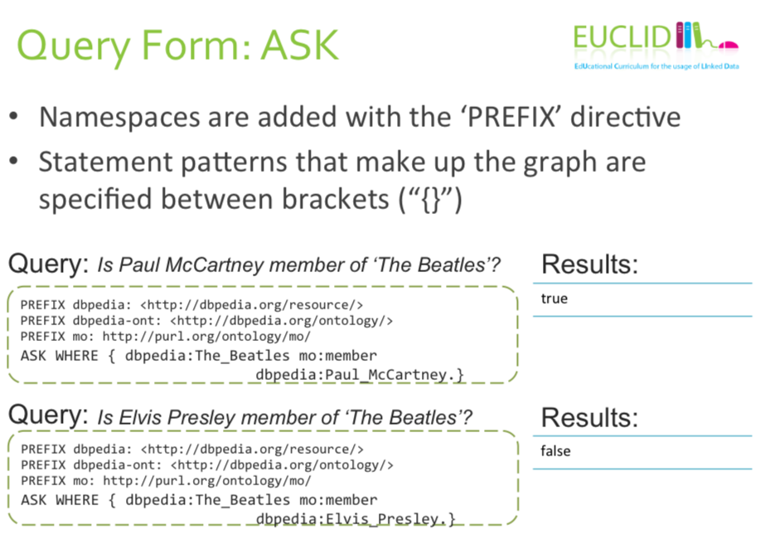

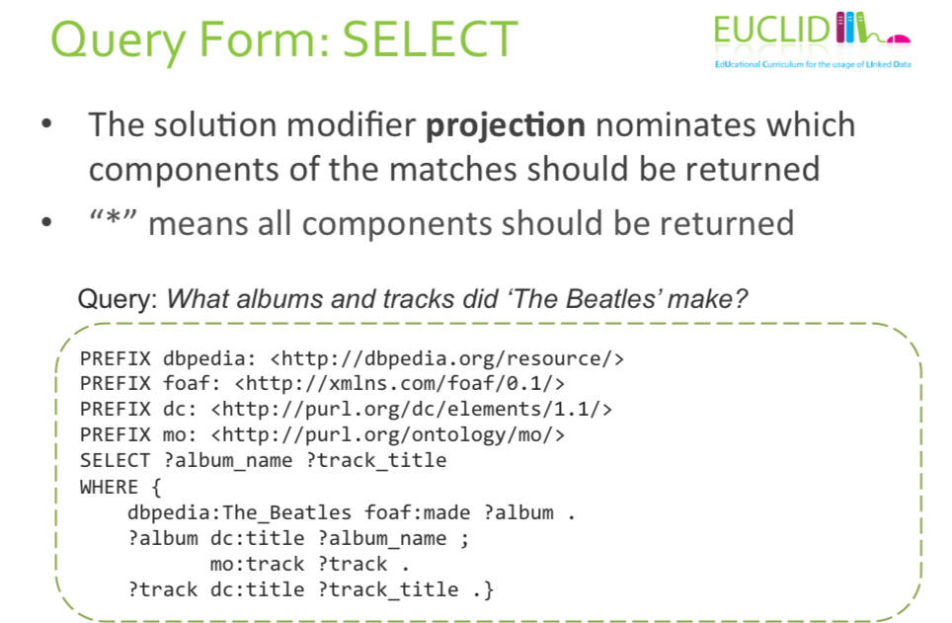

The solution modifier express express the variables that we want back

You are making a projection, express the variable that you want to return

The query evaluation will return a table with 4 columns